For df_full (all features)

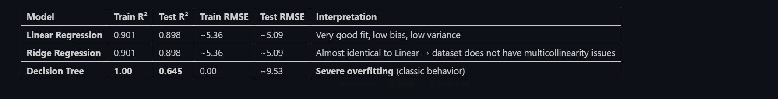

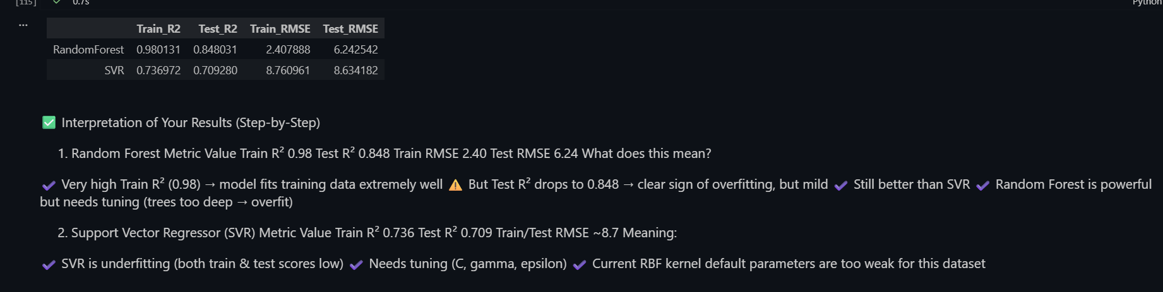

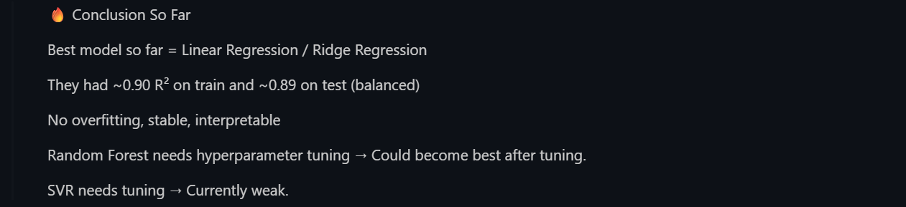

Doing hyperparamgter tunjg on random forest
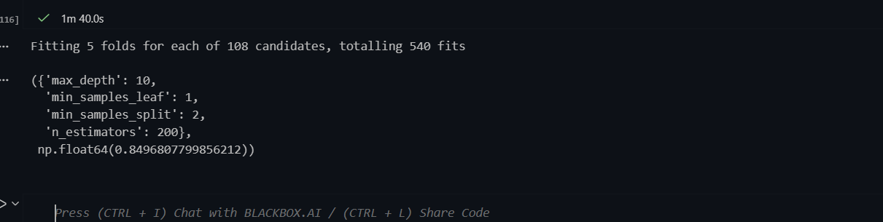

So we bases on this params we used for Randomfrest,
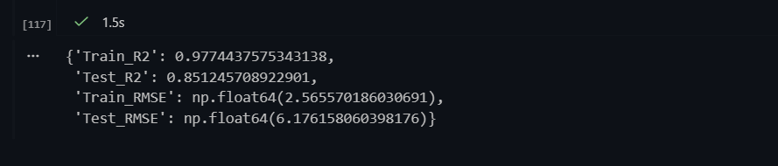

Model | Test R² | Test RMSE
Linear Regression | 0.898 | 5.09
Ridge Regression | 0.898 | 5.09
Decision Tree | 0.645 | 9.53
Random Forest (Default) | 0.848 | 6.24
Random Forest (Tuned) | 0.851 | 6.17

⭐ Tuned RandomForest is your best tree-based model
and Linear/Ridge are your best linear models.
Both are solid — but for deployment / Streamlit:
👉 Use Tuned Random Forest
because it captures non-linear patterns better.

For df_select (only slected features 5 features out of 16):
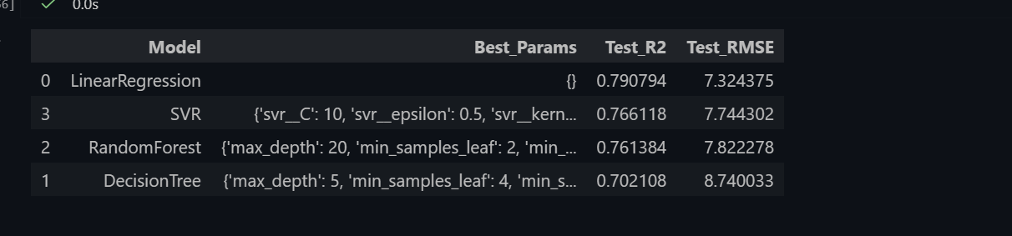

✅ Interpretation — What does this mean?
1️⃣ Linear Regression is the best model in Approach-2

Lowest Test_RMSE (7.32)

Highest Test_R2 (~0.79)

Very stable: not overfitting much and good generalization.

This makes sense because your selected features are mostly linear contributors:

Study hours

Attendance

Sleep

Mental health

Part-time job

These behave close to linear trends → linear regression naturally performs best.

2️⃣ SVR performed well — but slightly worse than Linear Regression

SVR shows:

Good R²

Slightly higher RMSE

Why?
👉 SVR shines when relationships are non-linear.
Your selected 5 features are mostly linearly correlated, so Linear Regression naturally fits better.

Still, SVR performance is strong and stable.

3️⃣ Random Forest and Decision Tree lower in performance

Because:

You used only 5 features

Data relationships are simple

Trees tend to overfit small feature spaces

Tree-based models shine more in complex, high-dimensional datasets (like your Approach-1 with all features).

🔥 Conclusion for Approach-2

✔ Best model = Linear Regression
✔ No overfitting
✔ Most interpretable
✔ Lowest error

## I am selecting approach 2 :(linear regression)

1️⃣ Random Forest was overfitting in Approach 1

Even though tuned RF had a good Test_R² (~0.851), it had:

- Train R² = 0.977

- Test R² = 0.851

- A big gap → overfitting

RF memorized patterns in training data but didn’t generalize as well.

👉 Linear Regression had:

- Train R² ≈ 0.90

- Test R² ≈ 0.898

- Very small train–test gap

- Better generalization

⚠️ Generalization is more important than just getting a slightly higher R².

2️⃣ 2nd Approach = Feature-Selected + Interpretable Model

Approach 2 uses only meaningful features and results in:

- A simpler, cleaner, more explainable model

- Linear Regression → easy to interpret coefficients

- Perfect for a Streamlit demo

- Matches typical academic/industry teaching practices

Random Forest is a black box — harder to explain in an interview.

3️⃣ The goal is not just accuracy — it’s balanced performance

A model should:

- Generalize well

- Be stable

- Be interpretable

- Avoid overfitting

- Linear Regression satisfies these better than the tuned RF in your case.

4️⃣ The difference in performance was NOT big enough

The tuned Random Forest gave:

- Test_RMSE ≈ 6.17

- Test R² ≈ 0.851

Linear Regression in your selected features approach gave:

- Test_RMSE ≈ 7.32

- Test R² ≈ 0.79

The aim here is:

end-to-end model building

not necessarily maximize accuracy at all cost

